### **Classroom Activity:** **Implement a Counter which Increment and Decrement the counts using useReducer**

#### **CounterComponent.js**

This component will use the useReducer hook to manage the state of a counter.

**Code :**

|  |
| --- |
| import React, { useReducer } from 'react';  // Define the initial state and the reducer function  const initialState = { count: 0 };  function reducer(state, action) {  switch (action.type) {  case 'increment':  return { count: state.count + 1 };  case 'decrement':  return { count: state.count - 1 };  default:  throw new Error();  }  }  const CounterComponent = () => {  const [state, dispatch] = useReducer(reducer, initialState);  return (  <div>  <h1>Counter</h1>  <p>Count: {state.count}</p>  <button onClick={() => dispatch({ type: 'increment' })}>Increment</button>  <button onClick={() => dispatch({ type: 'decrement' })}>Decrement</button>  </div>  );  };  export default CounterComponent; |

#### **App.js**

This file will import and use the CounterComponent to demonstrate the useReducer functionality.

code:

|  |
| --- |
| import React from 'react';  import CounterComponent from './CounterComponent';  function App() {  return (  <div className="App">  <header className="App-header">  <h1>My React App</h1>  <CounterComponent />  </header>  </div>  );  }  export default App; |

### **Output**

When you run the React app, you will see a counter with buttons to increment and decrement the count.

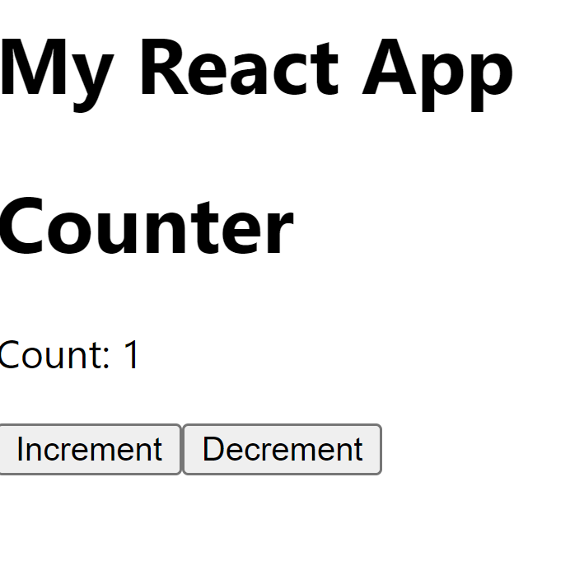

**Execution Steps:**

1. Create a new React project if you don't have one already:
   * If you don't have a React project, create one using the command: npx create-react-app my-app.
2. Create a file named CounterComponent.js in the src folder and write the code in the file.
3. Update App.js:
   * Replace the contents of App.js with the code provided to import and use the CounterComponent.
4. Save the files:
   * Ensure that CounterComponent.js and App.js are saved after making the changes.
5. Run your React app using the terminal command:
   * Open your terminal.
   * Navigate to the project directory and run the command: npm start.
6. View the output:
   * Open your browser and go to http://localhost:3000.
   * You should see the counter with buttons to increment and decrement the count.